INSTITUTIONAL BROCHURE

CITEP Knowledge Series

for chambers, associations and promotional agencies
  - Turn information into informed action—and deliver greater value to every member.


Strengthen your role in business development
Chambers of Commerce connect businesses with institutions, government, technology, finance and markets. The CITEP Knowledge Series helps your team turn that position of trust into practical, high-value support for members.
Each module converts complex information on entrepreneurship, MSMEs, technology, markets, finance and exports into clear guidance that can be used in programmes, advisory services and member engagement.

Why this matters now
Information is abundant. What businesses need is trusted help to identify what is relevant, assess feasibility and move confidently towards implementation.
The real challenge is to understand:
- Which opportunity is relevant?
- How should it be evaluated?
- What technology or know-how is required?
- Which market should be targeted?
- What finance and support are available?
- What procedures need to be completed?
- What practical steps should be taken?
CITEP closes this gap with structured, practical and action-oriented knowledge.

Seven connected knowledge areas
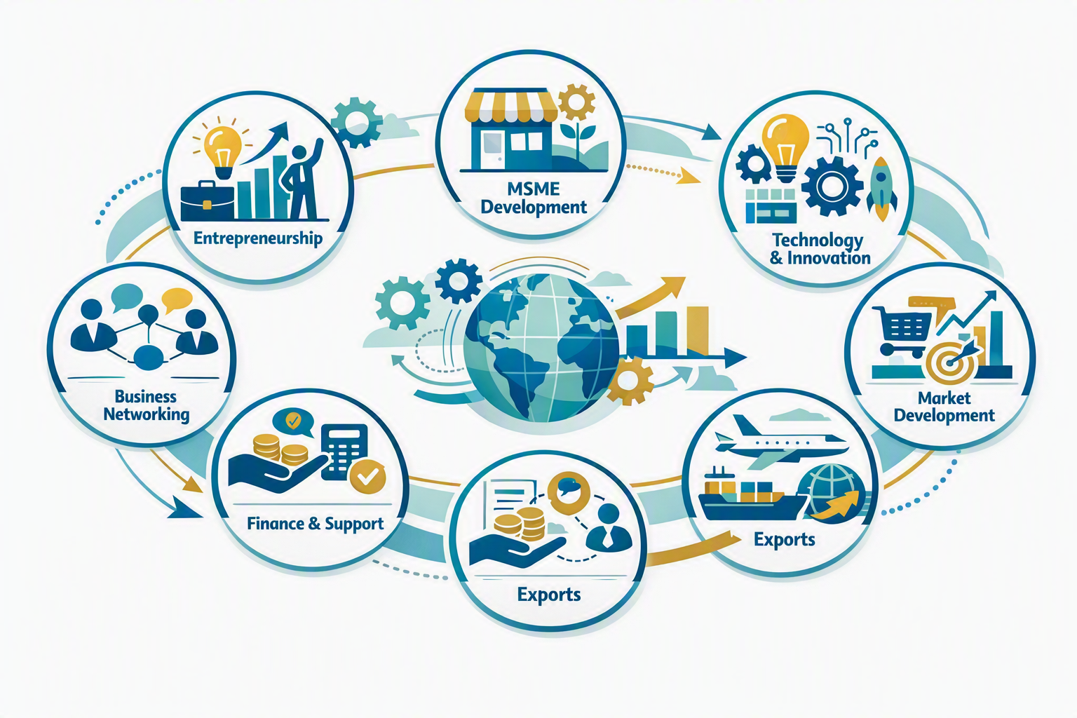
Entrepreneurship
Business ideas, opportunity evaluation and enterprise development.
MSME Development
Technology, product development, process improvement and market entry.
Technology & Innovation
Technology identification, adoption, upgrading and innovation opportunities.
Market Development
Domestic and international market identification and evaluation.
Export Development
Export basics, readiness, procedures, marketing, buyers and logistics.
Finance & Support
Finance, grants, concessions, subsidies and institutional support.
Business Networking
Business contacts, institutional linkages and opportunities for collaboration.

How your organisation can use the Series
The Knowledge Series can be used as a resource for:
- Member awareness programmes
- Business development initiatives
- Entrepreneurship programmes
- MSME support activities
- Export awareness programmes
- Technology awareness
- Training and orientation
- Business networking and promotion

Building Staff Capability in Exports & Entrepreneurship
Foundational knowledge in exports and entrepreneurship equips teams in chambers, associations, Indian missions abroad and promotional agencies to deliver higher-value services—from regulatory guidance and market connections to advocacy and investment facilitation.

Enhanced Advisory Capability
- Accurate Guidance: Staff can confidently navigate complex trade regulations, documentation, and compliance.
- Risk Mitigation: Enables staff to warn local businesses about common international payment and shipping pitfalls.
- Market Intelligence: Staff learn how to analyze global market trends to identify lucrative export destinations for members.
- Programme Design: Staff can translate member needs into focused workshops, advisory clinics and business-development initiatives.
- Targeted Workshops: Staff can design impactful training sessions tailored to local entrepreneurial needs.
- Incubation Support: Helps agencies build effective business incubators that nurture startups from inception to export-ready status.
- Trade Missions: Enables staff to organize highly productive international trade shows and B2B matchmaking events.

Operational Efficiency & Credibility
- Faster Processing: Speeds up the issuance of critical trade documents like Certificates of Origin.
- Elevated Reputation: Positions the chamber or agency as a top-tier, authoritative industry resource.
- Policy Influence: Empowers staff to advocate effectively for pro-business government trade policies using data-backed insights.

Member Retention & Growth
- Value Creation: Provides tangible, revenue-generating services that justify membership dues.
- Network Expansion: Attracts ambitious, growth-oriented entrepreneurs to the organization's ecosystem.
- Success Stories: Creates measurable local economic impact, proving the agency's vital role in the community.
By combining practical information, informed advocacy, and targeted business support, chambers and trade associations can become stronger catalysts for international trade and entrepreneurship.
Our modules build capability progressively through clear, accessible learning. Over time, staff develop a practical understanding of international trade, export documentation, international marketing, logistics, trade finance, customs procedures, free-trade agreements, export incentives, global business practices, entrepreneurship, technology, joint ventures, and sector- and country-specific trade leads.

Subscription
First year: ₹10,000
Annual renewal: ₹2,500
The subscription gives your institution a practical reference library that staff can use throughout the year for member support, programme design and business facilitation.

From knowledge to enterprise
Knowledge → Opportunity → Evaluation → Action → Enterprise
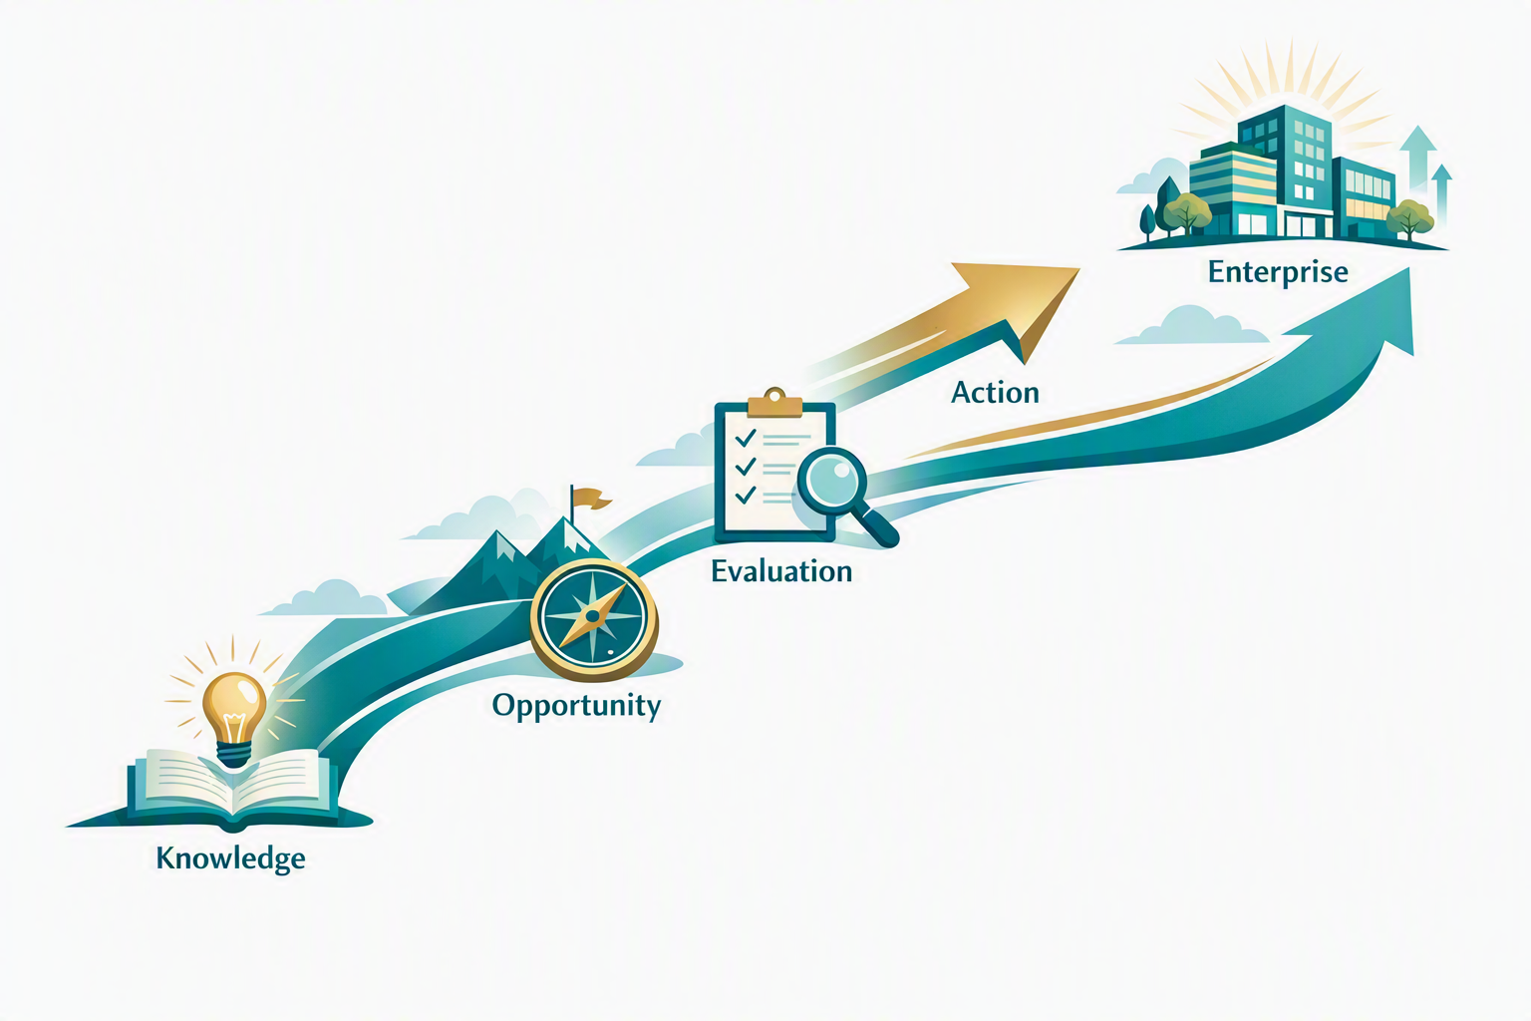
CITEP believes that information becomes valuable when it helps a business take the next practical step.

Important note
CITEP provides knowledge resources and facilitation-oriented information. Specific government schemes, financial assistance, approvals and other benefits are subject to the rules and decisions of the respective authorities.
Equip your team. Strengthen member services. Turn knowledge into implementation.
CITEP—Beyond Information. Towards Implementation.

