CITEP TRADE & COMMERCE DIRECTORY

A Practical Business Contact & Information Resource

THE RIGHT CONTACT CAN OPEN THE RIGHT OPPORTUNITY

Connecting Indian enterprise with wider markets, institutions and opportunities.
Business development often depends on identifying the right buyer, supplier, institution, technology source, financial institution, consultant or strategic partner.
However, locating relevant contacts can be time-consuming.
The CITEP Trade & Commerce Directory is conceived to help address this requirement by bringing together useful business and institutional contacts in a structured resource.

WHO CAN BENEFIT?
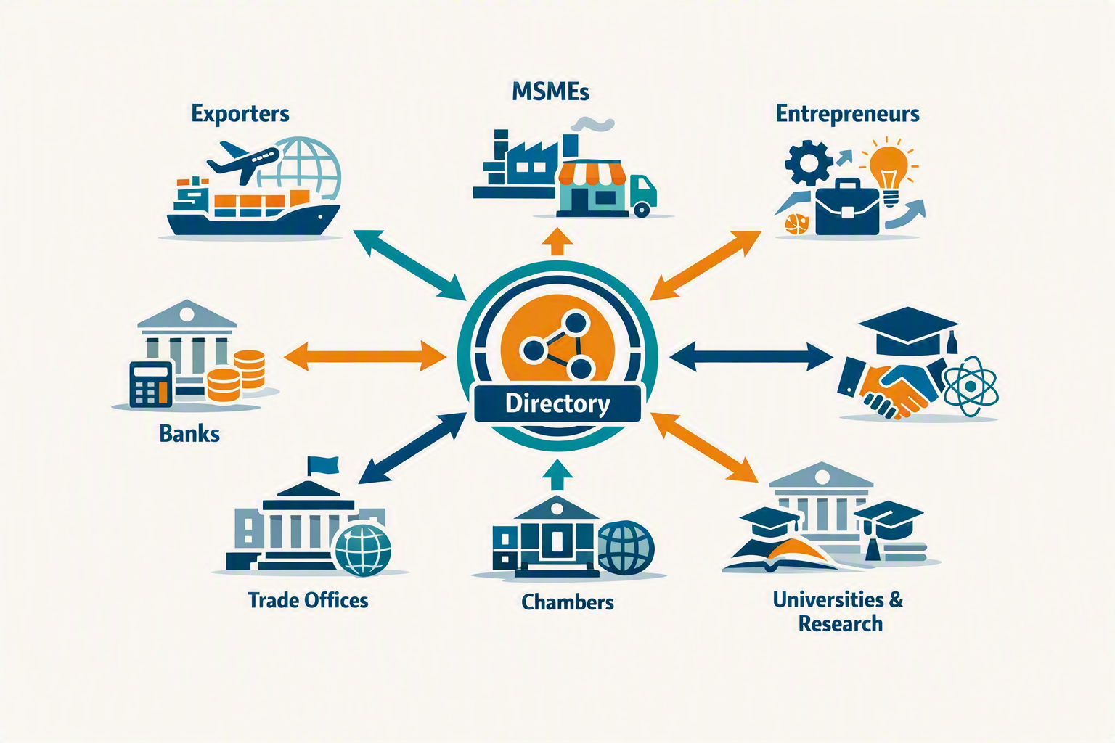
One directory, multiple pathways to trade, finance, knowledge and institutional support.

EXPORTERS
Identify potential buyers, suppliers, service providers and trade-related organisations.

MSMEs
Explore business contacts, technology sources, financial institutions and support organisations.

ENTREPRENEURS
Identify resources and contacts that may assist business development.

FINANCIAL INSTITUTIONS
Access relevant business and industry contacts for promotional, research and outreach purposes.

TRADE PROMOTION ORGANISATIONS
Use the Directory as a resource for identifying potential businesses and contacts.

INDIAN MISSIONS & TRADE OFFICES
Where appropriate, the Directory can provide a starting point for identifying Indian businesses and potential trade contacts.

CHAMBERS & TRADE ASSOCIATIONS
Support business networking, surveys and industry outreach.

EDUCATIONAL & RESEARCH INSTITUTIONS
Assist in research, surveys, industry interaction and institutional networking.

WHAT CAN THE DIRECTORY HELP YOU FIND?
The Directory is intended to cover, progressively, relevant contacts such as:
BUSINESSES
Manufacturers | Exporters | Importers | Buyers | Suppliers
FINANCE
Banks | Financial Institutions | Other Finance-related Services
TECHNOLOGY
Technology Providers | Know-how Sources | Research Organisations
PROFESSIONAL SERVICES
Consultants | Business Services | Legal / Accounting / Other Professional Support
TRADE & PROMOTION
Trade Promotion Organisations | Chambers | Industry Associations
INSTITUTIONS
Educational Institutions | Management Institutions | Engineering Institutions | Research Bodies
BUSINESS SUPPORT
Logistics | Certification-related Services | Marketing | Other Business Support

HOW CAN IT BE USED?

A practical route from discovery and research to relationships, trade and outreach.

1. BUSINESS PROMOTION
Identify organisations and contacts relevant to specific promotional activities.

2. MARKET RESEARCH
Support surveys, studies and research requiring business or institutional contacts.

3. BUYER / SUPPLIER SEARCH
Explore potential commercial contacts for further investigation and communication.

4. BUSINESS NETWORKING
Identify organisations with whom business relationships may be developed.

5. TRADE PROMOTION
Support promotional activities undertaken by organisations involved in trade and export development.

6. INSTITUTIONAL OUTREACH
Assist institutions in identifying organisations for surveys, studies, programmes and collaboration.

A DEVELOPING RESOURCE
The CITEP Trade & Commerce Directory is intended to develop progressively as CITEP expands its network.
The Directory may therefore evolve to include additional categories, sectors, locations and international contacts.

IMPORTANT NOTICE
Directory information is provided as a business-information and contact resource.
CITEP does not represent or guarantee the commercial credentials, financial standing, quality, performance or suitability of any listed organisation.
Users should independently verify relevant information and conduct their own due diligence before entering into any business, financial or professional relationship.

SUBSCRIPTION

FIRST YEAR

₹10,000/-

ANNUAL RENEWAL

₹2,500/-
Subscribe to the CITEP Trade & Commerce Directory

CITEP
CENTRE FOR INDIAN TRADE AND EXPORT PROMOTION
Beyond Information. Towards Implementation.

